21.52: The earth’s electric field is 150 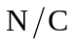, directly downward. So, 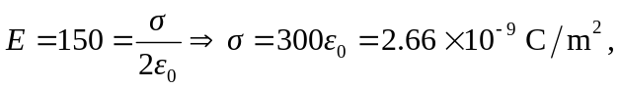 and is negative.

